Heritage Volunteer
Bringing the theatre building to life! Welcoming customers into the Cornwall Playhouse Auditorium, Greenroom Café and Playhouse Bar during the day. Providing guidance and information and engaging visitors with the rich history and heritage of the venue.
You’ll be responsible for
Being present within the Cornwall Playhouse auditorium and Playhouse Bar during the daytime, ensuring the areas are kept safe and secure. You will proactively assist customers visiting the venue by providing general information e.g. how to book tickets, seating questions and opening times, as well as engaging visitors with the history and heritage of the venue, using our 10 ‘Story Points’ as a guide. You will also be involved in assisting with backstage tours to groups and members of the public.
What you will deliver: it’s all about…
… delivering the customer experience | …developing the business
Demonstrating high standards of customer service and care when assisting visitors.  Bringing the vast history and heritage of the building to life, and engaging visitors.  Providing information and guidance about the theatre and its offering e.g. box office queries, opening times, accessibility, the stage programme and Get Creative activities. | Keeping up to date with special promotions and new initiatives within the organisation.  Providing information to customers on scheduled backstage and heritage tours and how to book onto these.
… incorporating Health & Safety | …being part of the team
Keeping an eye out for items that might be out of place each time you pass through an area or any hazards.  Understand the building evacuation procedures and the processes to follow in the event of an evacuation.  Helping achieve our H&S compliance by keeping all areas clean and tidy. | Treating others with kindness and respect. Being reliable and flexible, you will be prepared to volunteer where needed with a can-do positive attitude.  You understand that good teams are diverse teams, and at HfC ‘we’re all in!’
…managing risk | …making the link to our charitable purpose
Assisting diplomatically and swiftly with customer questions and concerns, handing any issues over to the Senior Responsible Officer on duty. | Able to advise visitors on all aspects of the heritage of the building, to bring the history alive.  Helping our audiences understand and value our work. Encouraging repeat custom, so that all surpluses can be reinvested in HfC’s core mission.

Scale and scope of the role |  |  | Knowledge, skills and experience needed
Reports to | Senior Responsible Officer on shift |  | Essential  Good standards of personal presentation and smart appearance.  Able to spend much of the duty standing and walking around the building.  Polite and personable with a can-do attitude.  A people person; willing to approach and engage with visitors.  Reliable and conscientious.  A keen interest in history and heritage.  Able to volunteer at least once a week (around holidays and other commitments).  Desirable  Experience as a volunteer or employee in a heritage role e.g. museum steward, room guide or tour guide.  Experience in a customer service role.  An interest in theatre and theatre history.
Financial responsibility | None
Line management | Front of House Manager
Working patten | Duties between 11:00-15:00, Monday to Saturday, split into two-hour duties i.e. 11:00-13:00 or 13:00-15:00.

THE WELCOME TEAM
At HFC we put the customer experience at the centre of our business - because if our audiences are having a good time, they will come back for more. We expect everyone in the Welcome Team to engage with our customers in a friendly and professional way, wherever they are in the building. Everyone in the team should know what is coming up on the main stage and what our hospitality offer is, so that they can make recommendations and deal with enquiries easily and quickly.
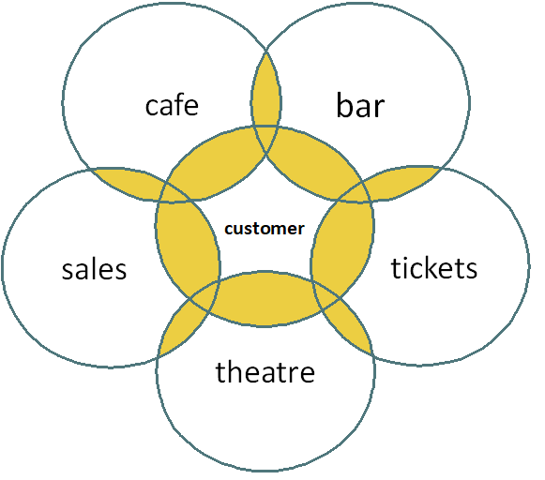
welcome
team!
Passion  We are dedicated, brave, heartfelt, loving. | Empathy  We are considerate, open, understanding, inclusive. | Grit  We are determined, tireless, grounded, focused. | Gusto  We are playful, enthusiastic, imaginative, hungry.

HFC values: how we behave
When it comes to the future of Cornwall, to entertaining our diverse audience, to meeting people as they are and providing everyone with opportunities to experience the thrill and power of performance, we’re all in.

